Upon Running this:

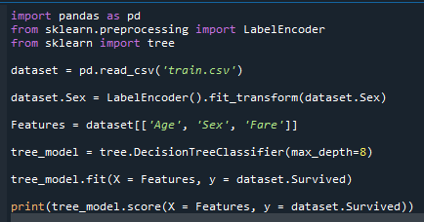

and



We get the output:



So, with only Features being: Sex, Age and Fare and max depth being 8, we get a score of: ]

***0.8706411698537683***

And a Tree dot file:



Upon running this file on webgraphviz.com we get a tree that looks like:

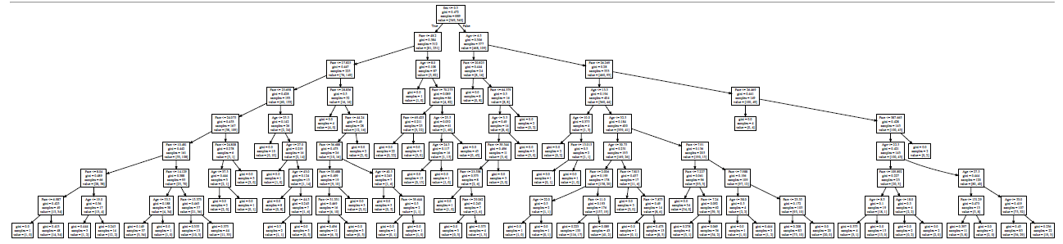

The Rule-set is:

1. If passenger is **Female** and **Fare** is **<= 6.987**, she **didn’t survive**
2. If passenger is **Female** and **Fare** is **<= 14.129** and **> 10.481**,while **Age** is **> 53.5**, she **didn’t survive**
3. If passenger is **Female** and **Fare** is **<= 24.808 and > 24.075**,while **Age** is **<= 37.5**, she **didn’t survive**
4. If passenger is **Female** and **Fare** is **<= 24.808 and > 24.075**,while **Age** is **> 37.5**, she **survived**
5. If passenger is **Female** and **Fare** is **<= 25.698 and >24.808**, she **didn’t survive**
6. If passenger is **Female** and **Fare** is **<= 25.698 and > 27.825**, while **Age** is **<= 25.5** , she **survived**
7. If passenger is **Female** and **Fare** is **<= 25.698 and > 27.825**, while **Age** is **> 25.5** and **<= 27** , she **didn’t** **survive**
8. If passenger is **Female** and **Fare** is **<= 25.698 and > 27.825**, while **Age** is **> 27** and **<= 43** , she **survived**
9. If passenger is **Female** and **Fare** is **<= 25.698 and > 27.825**, while **Age** is **> 44.5**, she **survived**
10. If passenger is **Female** and **Fare** is **<= 28.856 and > 27.825**, she **didn’t survive**
11. If passenger is **Female** and **Fare** is **<= 28.856 and > 44.24**, she **didn’t survive**
12. If passenger is **Female** and **Fare** is **<= 36.688 and > 33.688**, she **didn’t survive**
13. If passenger is **Female** and **Fare** is **<= 33.688 and > 31.331**, she **survived**
14. If passenger is **Female** and **Fare** is **<= 44.24 and > 36.688**, while **Age** is **<= 40.5**, she **survived**
15. If passenger is **Female** and **Fare** is **<= 39.644 and > 36.688**, while **Age** is >  **40.5**, she **survived**
16. If passenger is **Female** and **Fare** is **<= 44.24 and > 36.688**, while **Age** is **<= 40.5**, she **didn’t survive**
17. If passenger is **Female** and **Fare** is **> 48.2**, while **Age** is **<= 8**, she **didn’t survive**
18. If passenger is **Female** and **Fare** is **<= 69.425 and > 48.2**, while **Age** is **> 8**, she **survived**
19. If passenger is **Female** and **Fare** is **<= 70.275 and > 69.425**, while **Age** is **> 40.5**, she **didn’t survive**
20. If passenger is **Female** and **Fare** is **> 70.275**, while **Age** is **<= 24.5 and > 8**, she **survived**
21. If passenger is **Female** and **Fare** is **> 70.275**, while **Age** is **<= 25.5** and **> 24.5** , she **didn’t survive**
22. If passenger is **Female** and **Fare** is **> 70.275**, while **Age** is **> 25.5**, she **survived**
23. If passenger is **Male** and **Fare** is **<= 20.825** , while **Age** is **<= 6.5** ,he **survived**
24. If passenger is **Male** and **Fare** is **> 64.379** , while **Age** is **<= 6.5** ,he **survived**
25. If passenger is **Male** and **Fare** is **<= 64.379** and **> 39.344** , while **Age** is **<= 3.5** ,he **didn’t survive**
26. If passenger is **Male** and **Fare** is **<= 64.379** and **> 20.825** , while **Age** is **> 3.5** ,he **didn’t survive**
27. If passenger is **Male** and **Fare** is **<= 23.538** and **> 20.825** , while **Age** is **<= 3.5** ,he **didn’t survive**
28. If passenger is **Male** and **Fare** is **<= 29.062** and **> 23.538** , while **Age** is **<= 3.5** ,he **survived**
29. If passenger is **Male** and **Fare** is **<= 26.269** , while **Age** is **<= 10** and **> 6.5** ,he **survived**
30. If passenger is **Male** and **Fare** is **<= 15.015** , while **Age** is **<= 13.15** and **> 10** ,he **survived**
31. If passenger is **Male** and **Fare** is **<= 26.269** and **> 15.015** , while **Age** is **<= 13.5** and **> 10** ,he **didn’t survive**
32. If passenger is **Male** and **Fare** is **<= 2.006** , while **Age** is **<= 22** and **> 13.5** ,he **didn’t survived**
33. If passenger is **Male** and **Fare** is **<= 2.006** , while **Age** is **<= 30.75** and **> 22** ,he **survived**
34. If passenger is **Male** and **Fare** is **<= 7.815** , while **Age** is **<= 32.5** and **> 30.75** ,he **didn’t survive**
35. If passenger is **Male** and **Fare** is **<= 7.875** and **> 7.815** , while **Age** is **<= 32.5** and **> 30.75** ,he **survived**
36. If passenger is **Male** and **Fare** is **<= 7.227** , while **Age** is **> 32.5** ,he **didn’t survive**
37. If passenger is **Male** and **Fare** is **<= 7.988** and **> 7.91** , while **Age** is **<= 38** and **> 32.5** ,he **didn’t survive**
38. If passenger is **Male** and **Fare** is **<= 26.625** and **> 23.35** , while **Age** is **> 32.5** ,he **didn’t survive**
39. If passenger is **Male** and **Fare** is **<= 26.469** and **> 26.629** ,he **survived**
40. If passenger is **Male** and **Fare** is **> 387.665** ,he **survived**
41. If passenger is **Male** and **Fare** is **<= 109.892** , while **Age** is **<= 22.5** and **> 8.5** ,he **didn’t survive**
42. If passenger is **Male** and **Fare** is **<= 387.665** and **> 109.892** , while **Age** is **<= 18** ,he **survived**
43. If passenger is **Male** and **Fare** is **<= 387.665** and **> 109.892** , while **Age** is **<= 22.5** and **> 18** ,he **didn’t survive**
44. If passenger is **Male** and **Fare** is **<= 387.665** and **> 151.29** , while **Age** is **<= 27.5** and **> 22.5** ,he **didn’t survive**